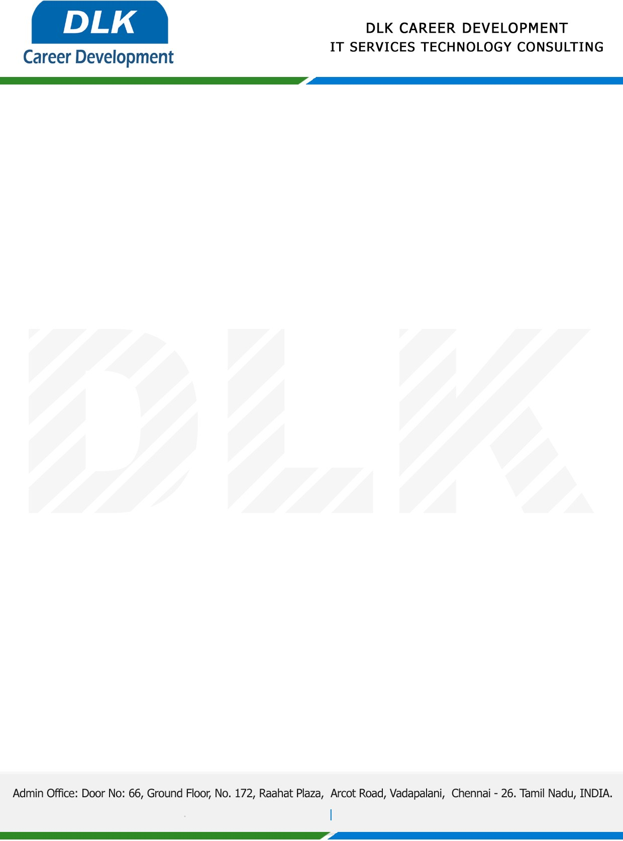

Date: 06/March/2023

**To**

Department of B.E (Computer Science Engineering) [,](https://www.cseindia.org/)

Head of Department,

Loyola Institute of Technology, Chennai -  600123.

**Sub: Letter of Internship Acceptance**

This is to certify that **MR DINESH M(REG NO:** **210920104012)** third year student of has accepted the Internship Work duration from **07th March 2023 to 07th April 2023** under the domain **“Java”.** During the internship,all information and data collected from you should be kept confidential.

We appreciate your interest in **DLK CAREER DEVELOPMENT**

